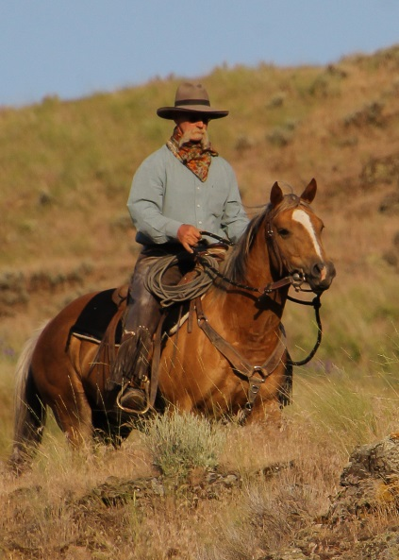
Keith Danielson
Horsemanship/Obstacle Trail Clinic & Challenge
for Intermediate/Advanced Riders
September 11-12 , 2021
Private Trail Course ~ St. Maries, Id ~ $300
Friends Hosting ~ Bobbi Smith & Sharon Cox

Keith is a talented trainer, breeder and clinician from Hooper, WA. He has won numerous trail competitions and challenges, including several Craig Cameron Extreme Cowboy Races, Ride the West, the “All Around” at the Bonina Ranch Trail Challenge and 3 times at the Wild Cowgirl Mtn. Trail Challenge. In 2018 he won back to back Cowboy Traditions Ranch ropings. You can learn more about him, his ‘plumb good horses’ and his clinics at www.hoopercrossingranch.com
Whether you are looking to advance your horsemanship, cow work, roping, compete, or just enjoy your horse more on the trails, the goal is to come away with that seemingly effortless ability to put your horse’s feet where you want, when you want. Keith teaches with patience and humor resulting in a better partnership between you and your horse.

This clinic format will be one full day of instruction and one day of judged competition. Join us for two fun filled days!
For more information and to sign up call or email …
Sharon Cox 208-568-0190 ~ twobearranch@gmail.com

